1. **DOWNLOAD AND INSTALL VIRTUALBOX**
   * 1. Download VirtualBox <https://www.virtualbox.org/wiki/Downloads>
     2. Run the .exe file to install VirtualBox.
2. **DOWNLOAD UBUNTU SERVER**
   * 1. Go to <https://ubuntu.com/download/server>. click the green button to download the iso file. Your download should start automatically.
3. **CREATE A VIRTUAL MACHINE**
   * 1. Open VirtualBox and click new from the top menu.
     2. 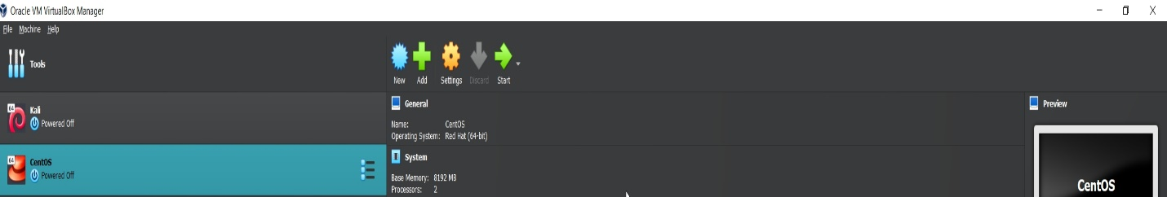
     3. You can choose any name for your virtual machine.
     4. Folder we will leave it at default.
     5. For **ISO IMAGE** select the drop-down menu and select other to open the explorer, navigate to the downloads, and select the previously downloaded ISO file.
     6. A screenshot of a computer

        Description automatically generated with medium confidence
     7. We can skip setting up the account as we will be doing it during the installation.
     8. For memory we can select **4096** to have at least **4GB** of ram available. If you wish to add more you can, it all depends on the availability of memory in your system.
     9. We will be using **2 CPU** cores for this installation.
     10. Create a new virtual disk with the default space selected of **20GB.**
     11. On the summary page make sure the configuration is ok according to the changes you selected. Then press finish.
4. **INSTALLING THE OS**
   * 1. Select the VM that we just created and from the top menu select start, to turn on the virtual machine.
     2. Press ENTER to select INSTALL UBUNTU SERVER. And wait for the processes to finish.
     3. Select your preferred language to continue.
     4. Choose whether to continue with updating the installer or continue without updating the installer.
     5. Press ENTER to select US keyboard. On the next page make sure the first option is selected. **It is automatically selected by default**.
     6. Text

        Description automatically generated
     7. Once selected press enter to continue.
     8. If you have a proxy server you can set it up on the next page, otherwise press enter to continue. Leave the mirror for images as default and press enter to continue.
     9. The hard drive for installation will be automatically selected. Press enter to continue.
     10. Text

         Description automatically generated
     11. **On the configuration summary make sure everything is ok. Press enter to continue, and confirm installation.**
     12. Create you account to sign into the server. **Make sure to remember your password!!.**
     13. Make sure to check to install OpenSSH to be able to log in to the server remotely. We will be needing it later.
     14. On the featured server snaps page select any additional features for your server**. For this install we will not be selecting any**.
     15. Once the installation is done, select reboot to finish the installation. Once it reboots you should be at the login prompt, so go ahead and log in.
5. **TESTING INTERNET ACCESS**
   * 1. To test internet access, we will be using the **ping** command. We will be pinging [www.google.com](http://www.google.com) to see if we get a response.
     2. Type in **ping** [**www.google.com**](http://www.google.com) and if your response looks like this then internet access works.
     3. Text

        Description automatically generated
6. **SHARE FILES USING WINSCP**
   * 1. We are going to test sharing files using **WINSCP.**
     2. First, we are going to change network settings to allow access from the program to the server.
     3. Shutdown the server using the **shutdown** command. It gives you about a minute for the server to shut down.
     4. Once the server is off select settings for the virtual machine.
     5. Go to the network settings. On the dropdown where it says attached to select bridged adapter. Where it says name select your adapter. It will look like this.
     6. **Graphical user interface, text

        Description automatically generated**
     7. After clicking ok start the virtual machine again and test internet access again using step 5.
     8. Download WinSCP by going to <https://winscp.net/eng/download.php> and install it.
     9. Make sure that the server is up and running again before we continue to the next step otherwise, please turn it on.
     10. Once the server is up and running, we will find the IP address for the server using the **ip addr** command.
     11. Depending on your network settings it may look different than mine but mine looks like this.
     12. **Text

         Description automatically generated**
     13. as you can see my IP address is **10.0.0.54.** yours might be different than mine.
     14. Open the WINSCP program we downloaded, and it should look like this.
     15. **Graphical user interface

         Description automatically generated**
     16. On the hostname we will put the IP address we found in one of the previous steps. For username and password, we will be using the account we created during the installation. Everything else should be left at default. Click the login button.
     17. Accept the notification that pops up and enter your password again on the next page.
     18. Once logged in you should see the directory of your server on the right side.
     19. Create a simple text file on the server. Click on the refresh button to update the directory.
     20. As you can see, I have already created one called hi.txt and it shows up on the WINSCP program.
     21. **Graphical user interface, text

         Description automatically generated**
     22. if you right click the file, you should have the option to download it. You can also do it the other way around to upload files to the server. And that is how we can share files using WINSCP.